Pathfinder to PrepSTEP: SAT and AP Practice Tests
- Go to the “Library Media Services” tab on the RPHS homepage.
To get there: fortbendisd.com /Schools / Ridge Point High School



- Under “Most Popular RPHS Links”, click the PrepSTEP link:
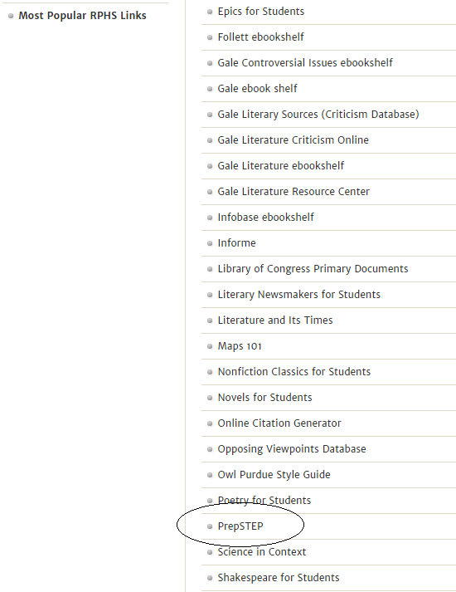

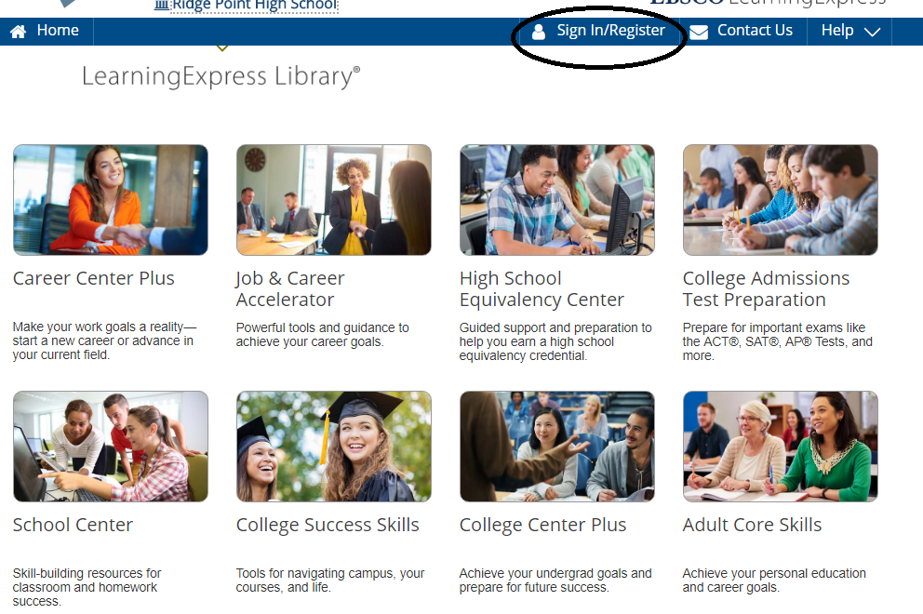
First time users: REGISTER using your school email and set your password.
Returning Users: This will be the Login each time you access PrepSTEP.

- To practice for SAT and AP tests, select College Admissions Test Preparation.

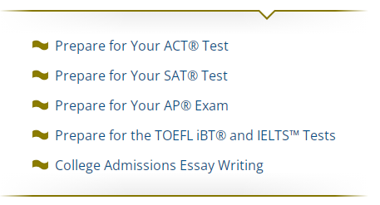

- Tailor the study session to fit your needs by selecting the mode in which you want to practice:
